**Q1. Revising the Select Query I**

Query all columns for all American cities in the CITY table with populations larger than 100000. The CountryCode for America is USA.

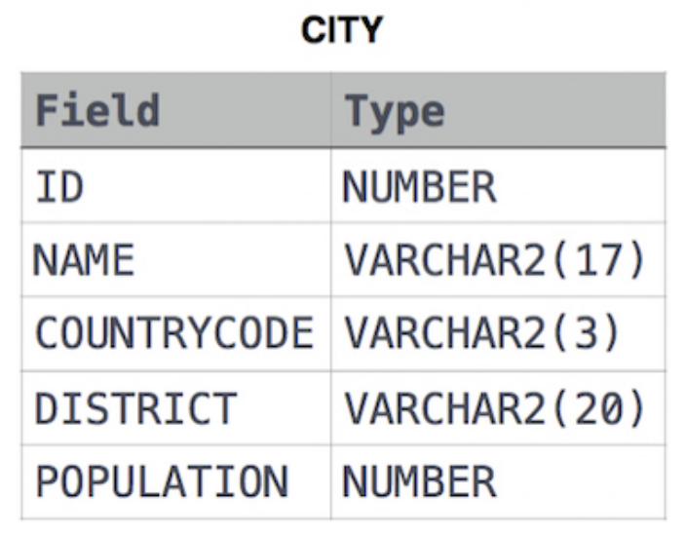The CITY table is described as follows:

Ans. -

SELECT *

FROM CITY

WHERE COUNTRYCODE = 'USA' AND POPULATION >100000